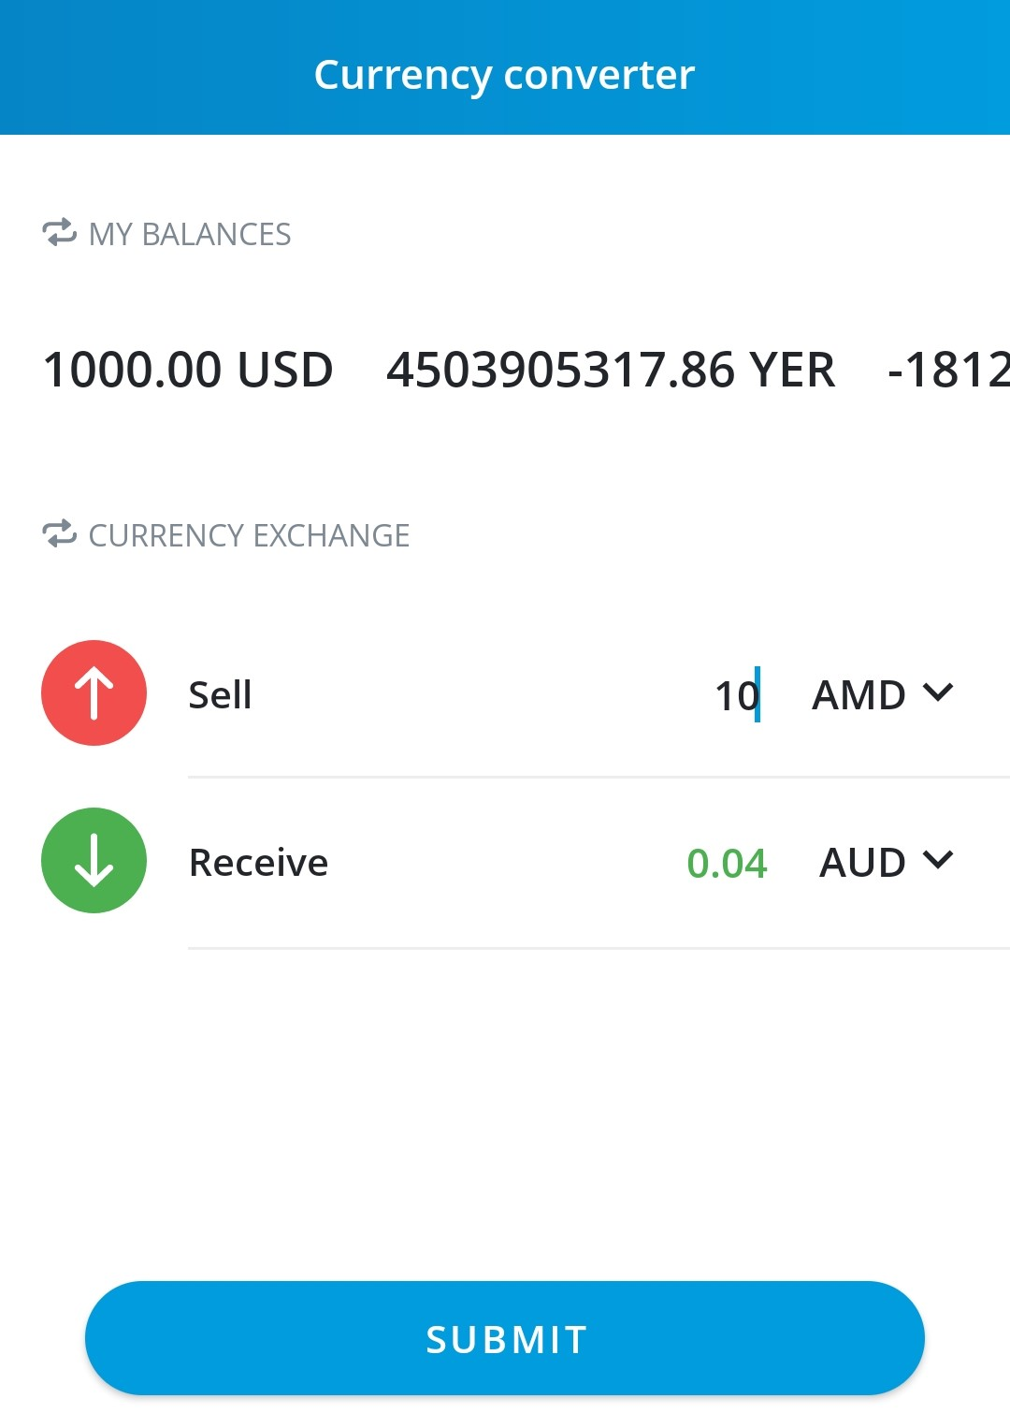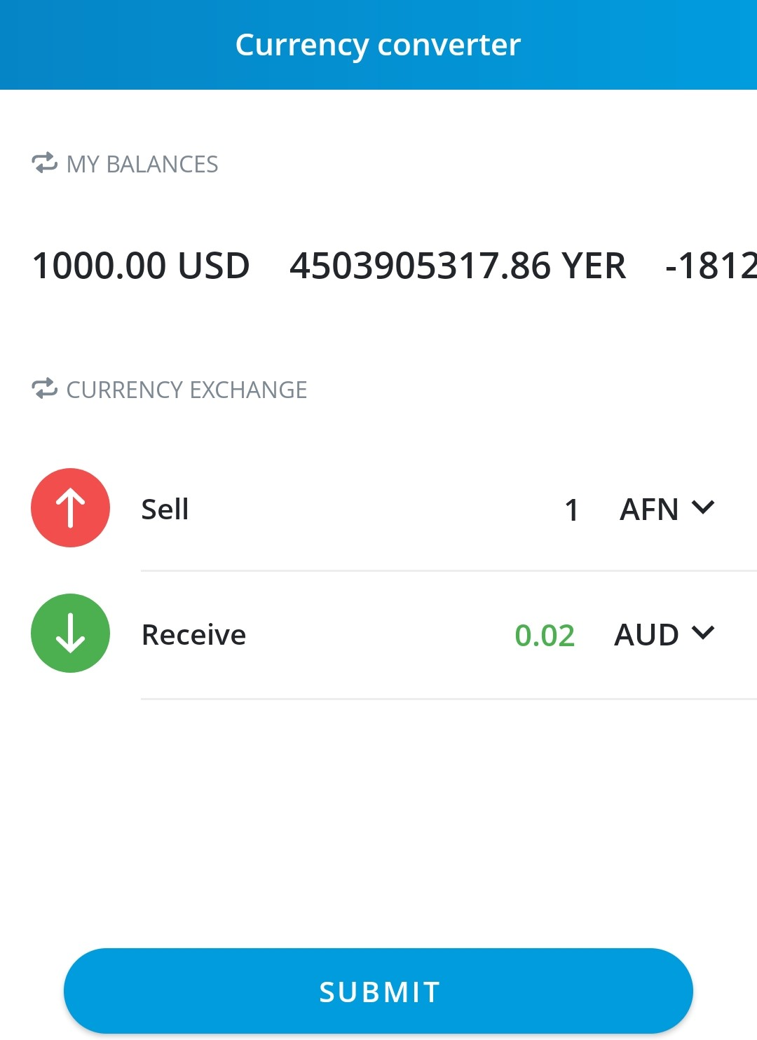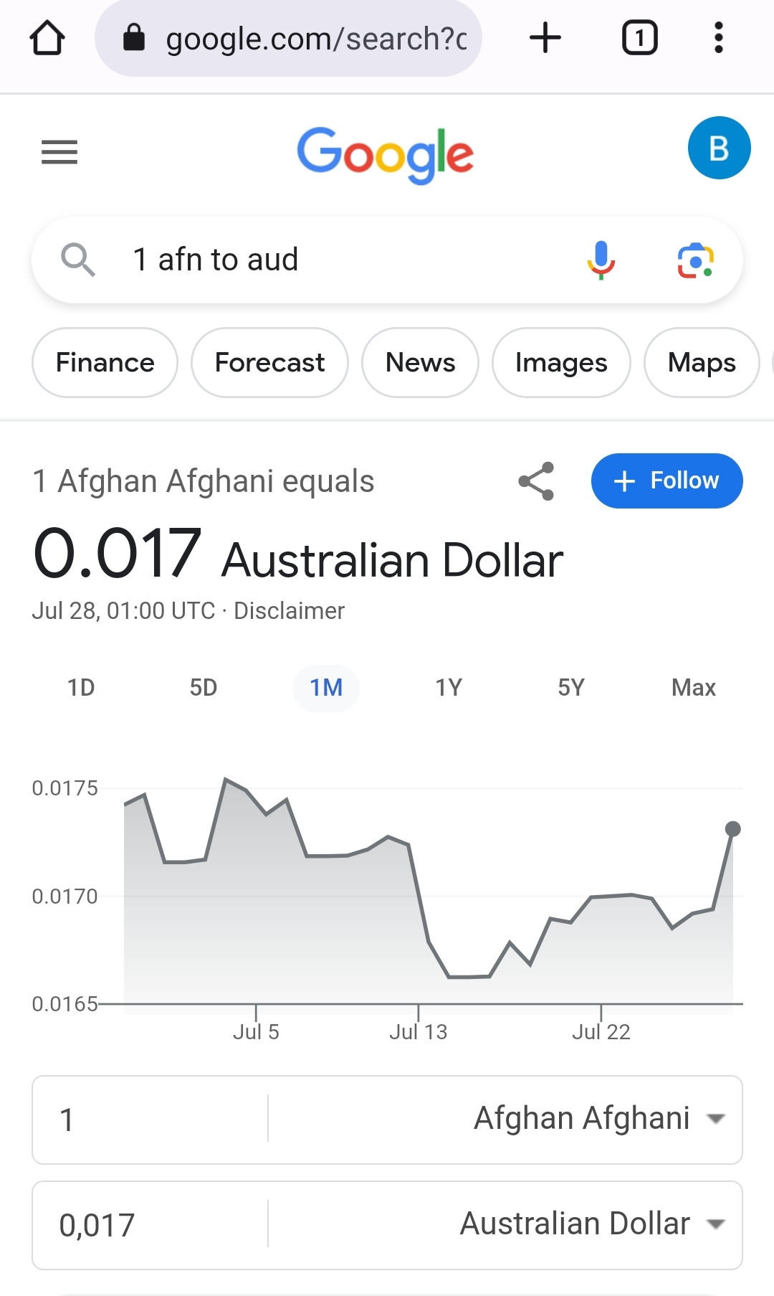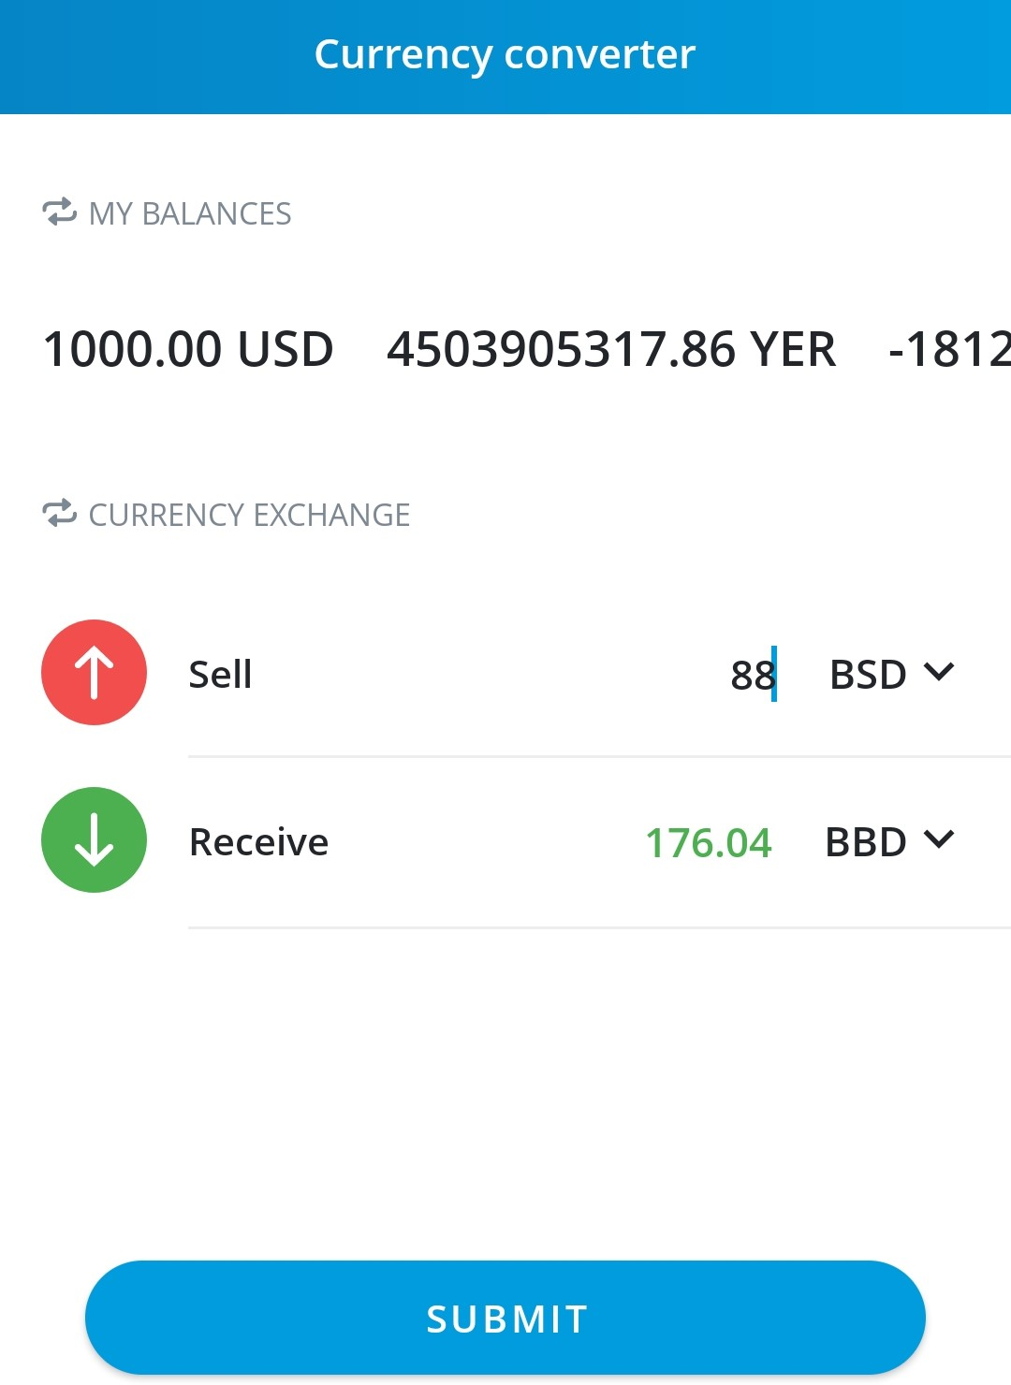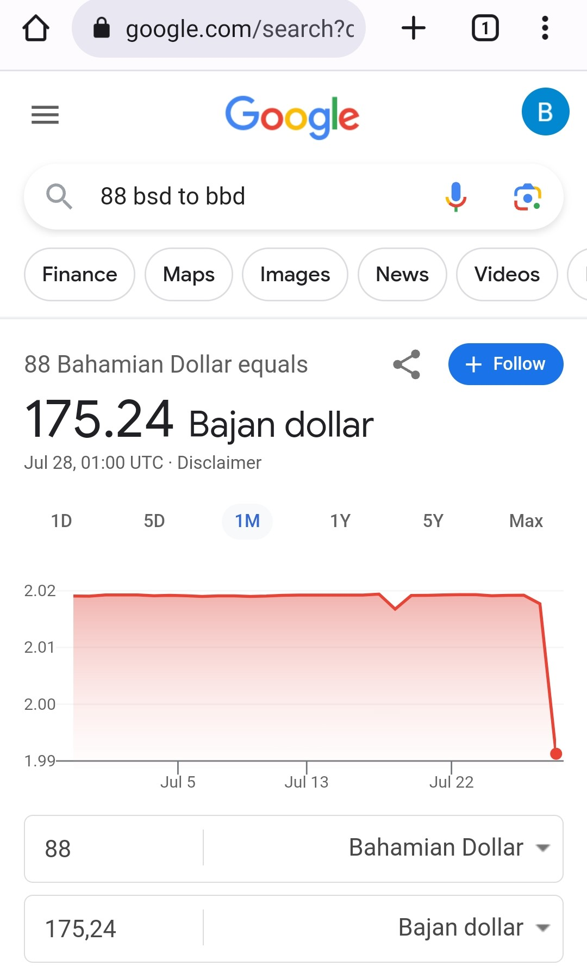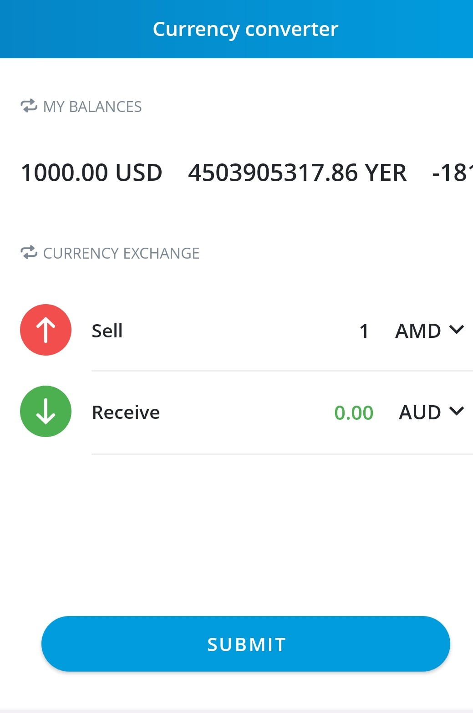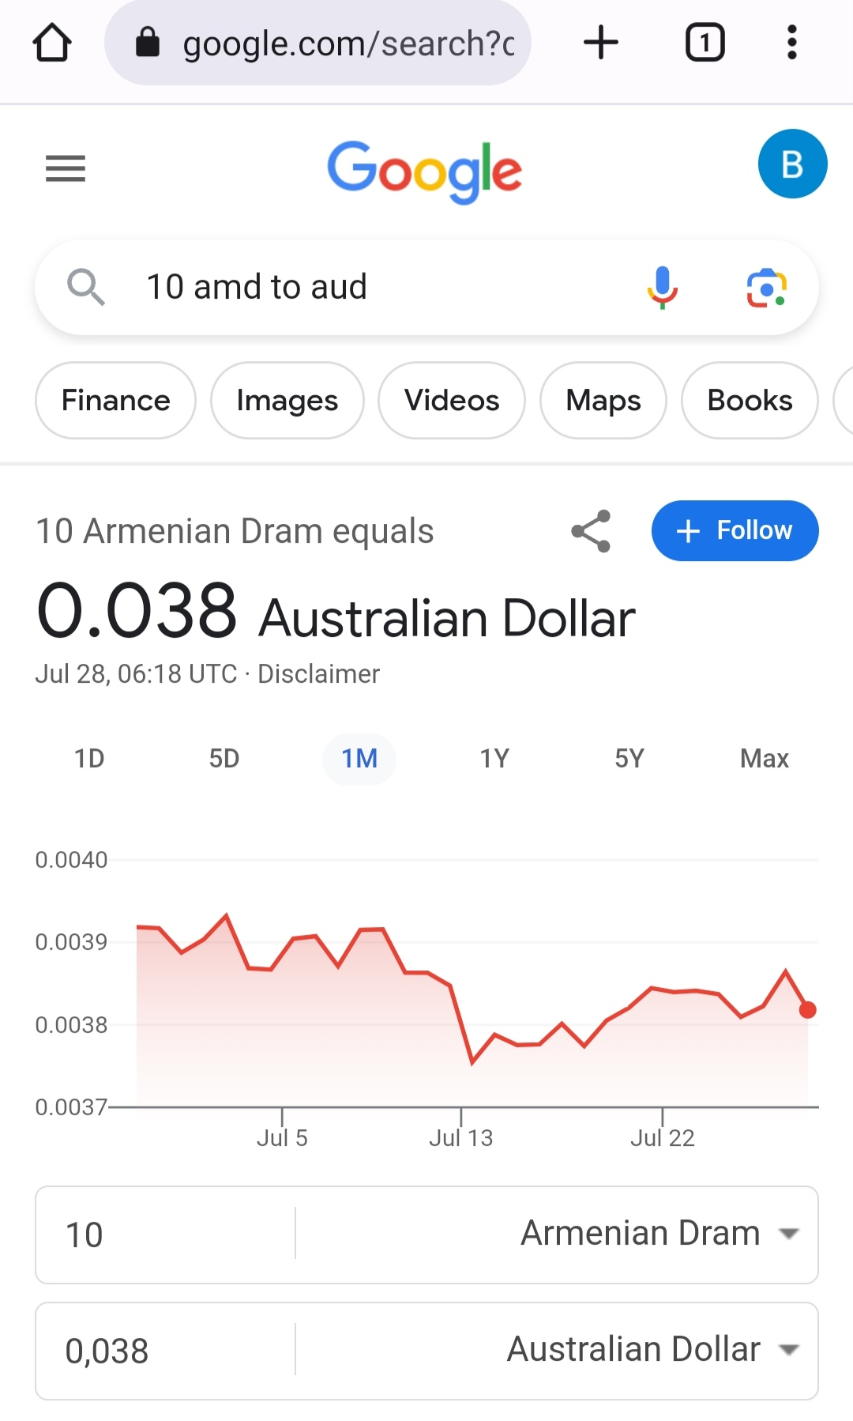

After checking all currencies and quotes, I noticed that they do not match the accuracy of the exchange rate at the moment (because of the rounding with the decimal point could). I tested all the drop-down menus, all the buttons and options for working with the application. It would be nice if there is an opportunity for friction or correction of the reserved values of quotes at the top – my balances. I found no option to reset my balance. 2 hours took me to test the application. When you open the drop-down menu for currency selection, your current choice of currencies is not visible. In my opinion, it would be nice to have an option to see.